SIMATS ENGINEERING
ASSESSMENT TOOL 1

COURSE NAME: COMPUTER NETWORKS
COURSE CODE: CSA07

COURSE OUTCOME COVERED

CO4:
Design network topologies star, mesh, bus, and hybrid using networking devices, transmission media, and cabling standards
(BL2,BL6)

Assessment Tool Weightage: 40%

QUESTIONS: 10 Total Marks:50

Annexure A

Coding challenge

Code of Conduct:

I R.HARI KRISHNAN(192565075) (Name / Reg No) certify that this submission is my original work and that I have adhered to the guidelines specified for this assessment.
I understand that any violation of academic integrity rules will result in disciplinary action.
Hari krishnan
Signature of the student:

Annexure A
Coding challenge
- Write a Python script that generates a star topology diagram (ASCII or graphical) given n hosts and a central switch. The script must print each host label, the switch name, and the connecting Cat6 UTP cable length.
- Code a function `validate_segment(length_m)` that returns True if the UTP segment is within IEEE 802.3 limits (≤100 m) and False with an error message otherwise. Include at least 3 test cases.
- Write a script that simulates CSMA/CD on a star topology with 4 hosts. Log every collision detection event and the back-off interval to a file named `csma_log.txt`.
- Using Python's `socket` library, write a client-server program that models two hosts communicating through a star switch. Demonstrate message forwarding by printing the switch's MAC address table after each frame transmission.
- Create a class `StarSwitch` with methods `add_port(host_id)`, `remove_port(host_id)`, and `broadcast(frame)`. Broadcast must send a frame to all ports except the source and log each delivery.

RUBRICS FOR CALCULATION

Criteria | Weightage | Exemplary (4) | Proficient (3) | Developing (2) | Beginning (1)
Problem Understanding | 15% | Fully understands the problem and requirements; no clarification needed | Understands most requirements with minor clarification | Partial understanding; misses some requirements | Poor understanding of the problem
Algorithm Design | 20% | Efficient, optimal, and well-structured algorithm | Correct algorithm with minor inefficiencies | Basic approach but not optimal | Incorrect or no clear algorithm
Code Quality | 15% | Clean, well-organized, readable, and properly formatted code | Mostly clean code with minor issues | Code is somewhat unclear or inconsistent | Poorly written, unreadable code
Functionality | 20% | Code works perfectly for all test cases | Works for most test cases | Works for limited cases | Does not run or fails major cases
Error Handling | 10% | Handles all edge cases and errors effectively | Handles some edge cases | Limited error handling | No error handling
Efficiency | 10% | Highly optimized in time and space complexity | Reasonably efficient | Some inefficiencies | Highly inefficient
Documentation & Comments | 5% | Clear and meaningful comments and documentation | Adequate comments | Few or unclear comments | No comments
Testing & Debugging | 5% | Thoroughly tested with multiple cases; no bugs | Tested with some cases | Minimal testing | No testing done

1. Write a Python script that generates a star topology diagram (ASCII or graphical) given n hosts and a central switch. The script must print each host label, the switch name, and the connecting Cat6 UTP cable length.
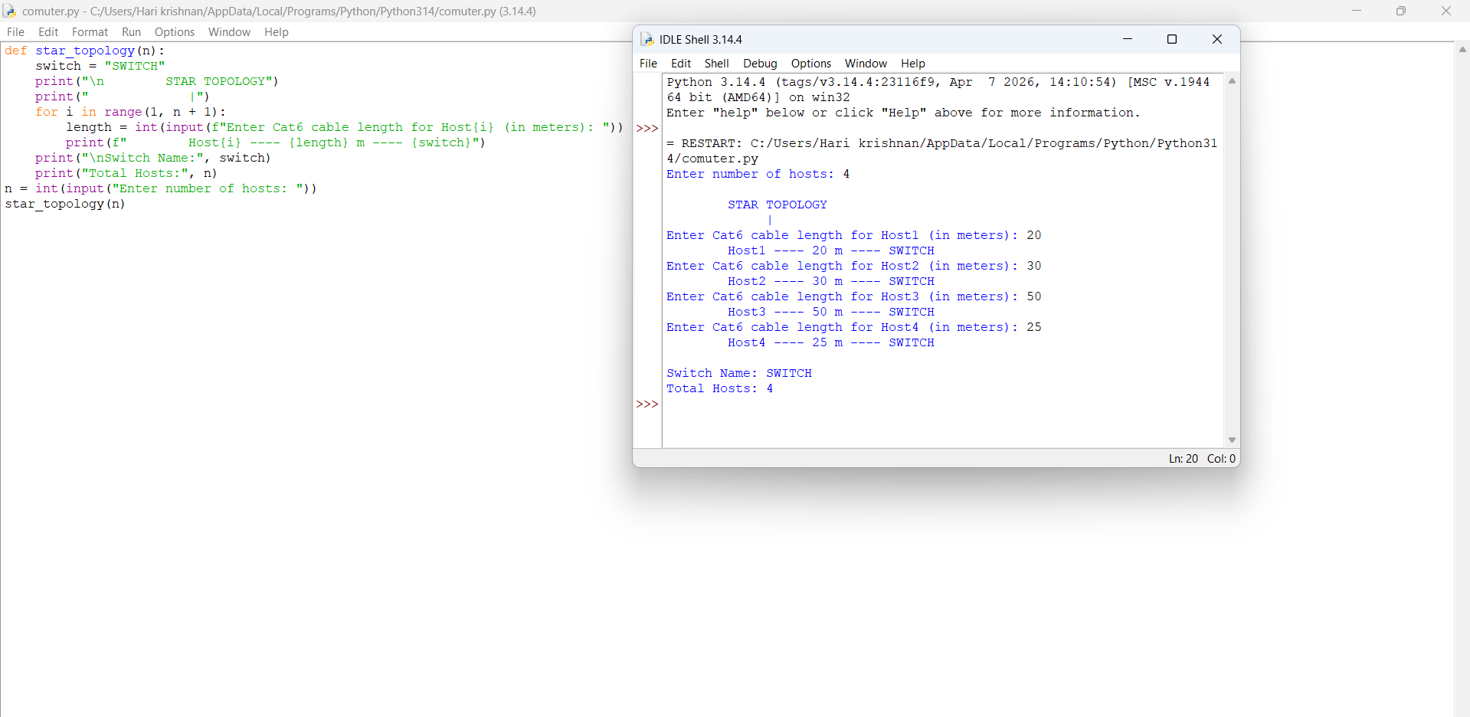

2.Code a function `validate_segment(length_m)` that returns True if the UTP segment is within IEEE 802.3 limits (≤100 m) and False with an error message otherwise. Include at least 3 test cases
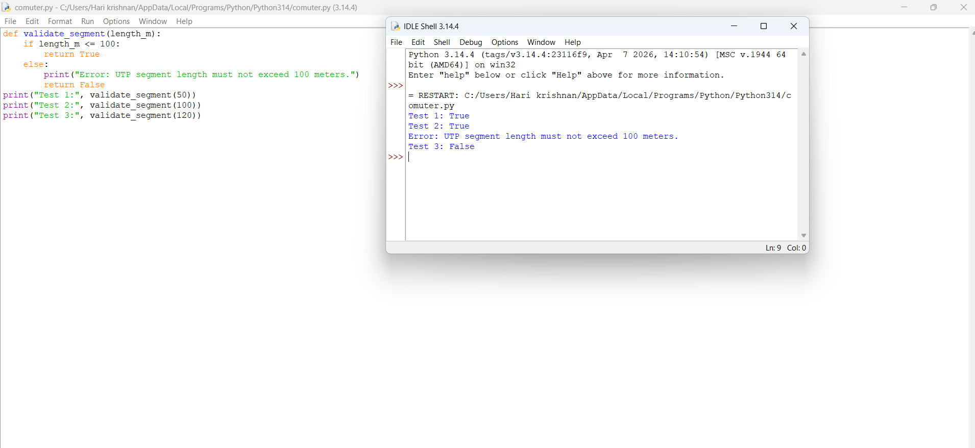

3. Write a script that simulates CSMA/CD on a star topology with 4 hosts. Log every collision detection event and the back-off interval to a file named `csma_log.txt`.
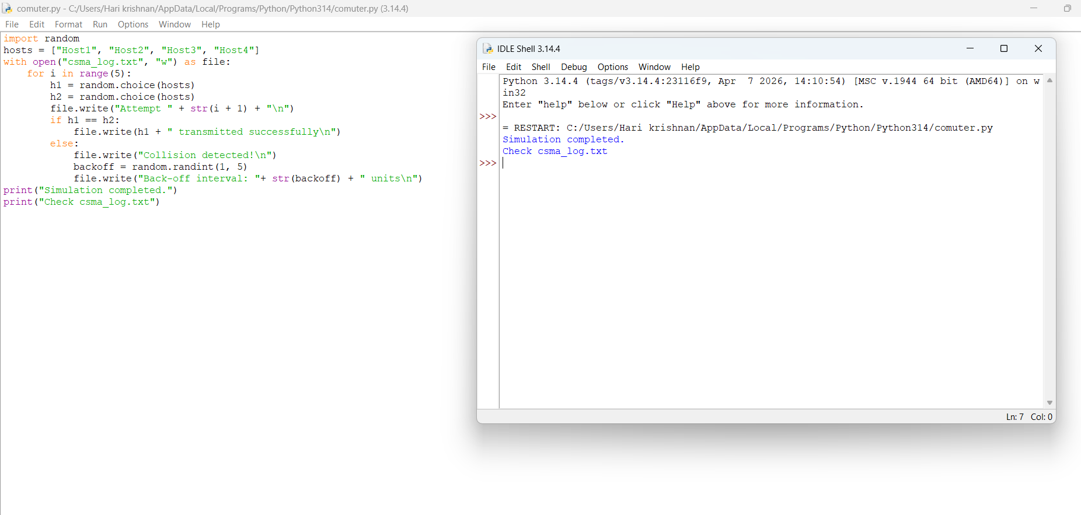

4. Using Python's `socket` library, write a client-server program that models two hosts communicating through a star switch. Demonstrate message forwarding by printing the switch's MAC address table after each frame transmission.
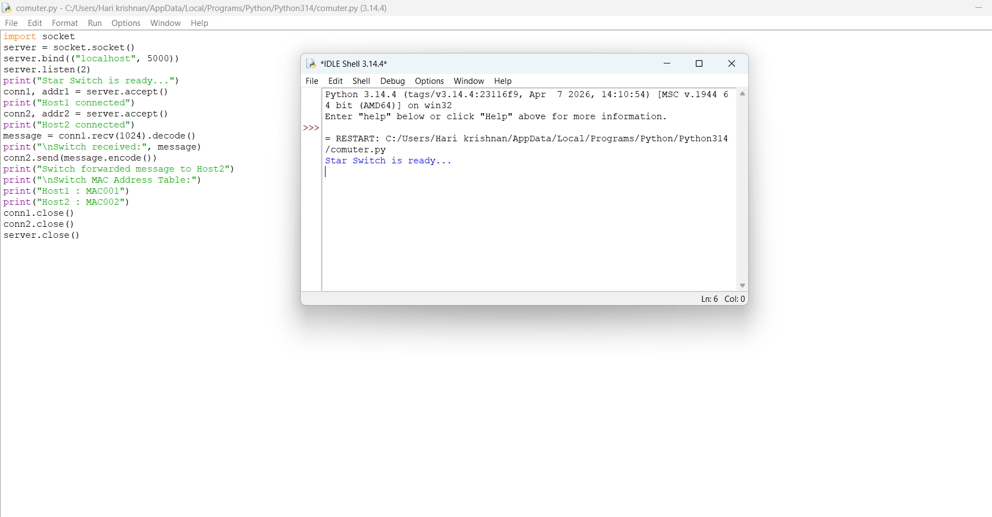

5.Create a class `StarSwitch` with methods `add_port(host_id)`, `remove_port(host_id)`, and `broadcast(frame)`. Broadcast must send a frame to all ports except the source and log each delivery
